chickey@deltalv.com

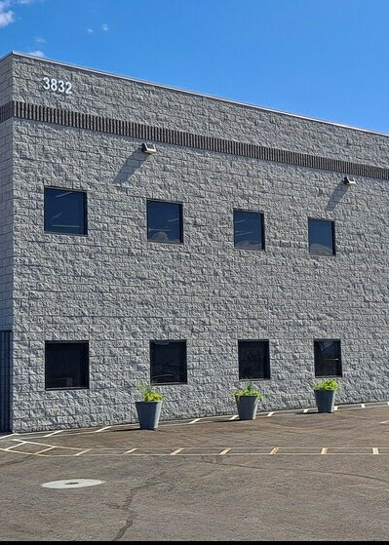
3842 Development Court
Las Vegas, NV 89115
Chris Hickey
Hickey Development
3831 Development Court rwilson@ndlgroupinc.com
(702) 465-0370

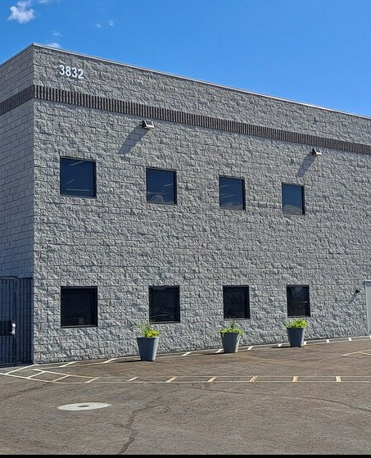
3842 Development Court
Property Type:
Industrial
Rentable Building Area:
6,118 SF
Rental Rate Mo:
$1.50 /SF/MO
Year Built: 2023
Property Subtype: Warehouse
Rental Rate: $18.00 /SF/YR
$18.00 /SF/YR

Brand New!!! 6,118 Sq/Ft Flex office /warehouse. Minutes from I-15 access. Private gated property with large fenced in yard. Fully built-out offices and restrooms with separate warehouse restroom. 1,290 Sq/Ft Mezzanine....
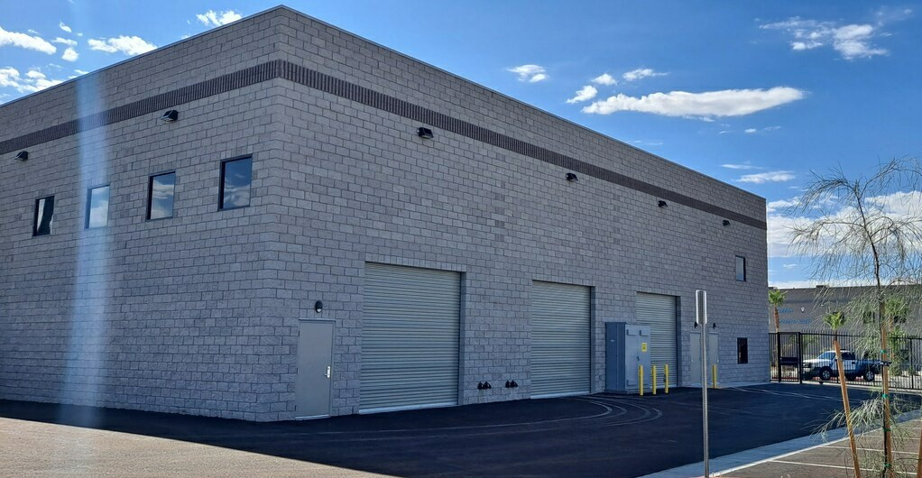
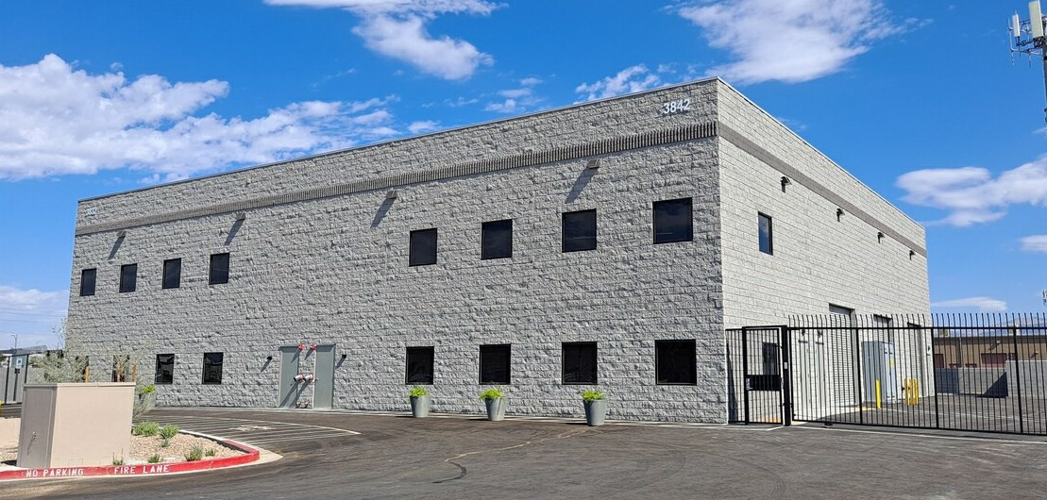
6,118 SF
$18.00 /SF/YR
Now
Triple Net (NNN) 1,290 SF
Relet Industrial
Negotiable
Space Available Rental Rate Date Available Service Type Office Size Space Type Space Use
Lease Term
1
Private gated street, Fenced yard w/ automatic gate, Storage mezzanine, Finished offices and restrooms, Finished breakroom, Warehouse restroom.
1st Floor
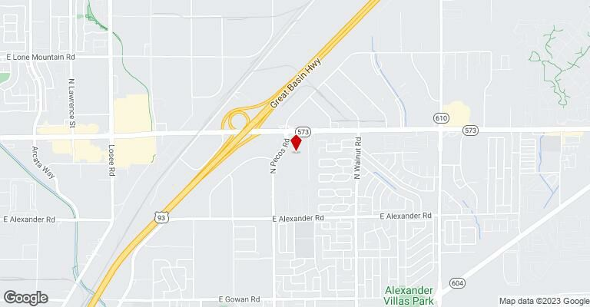

3842 Development Ct, Las Vegas, NV 89115

Brand New!!! 6,118 Sq/Ft Flex office /warehouse. Minutes from I-15 access. Private gated property with large fenced in yard. Fully built-out offices and restrooms with separate warehouse restroom. 1,290 Sq/Ft Mezzanine.
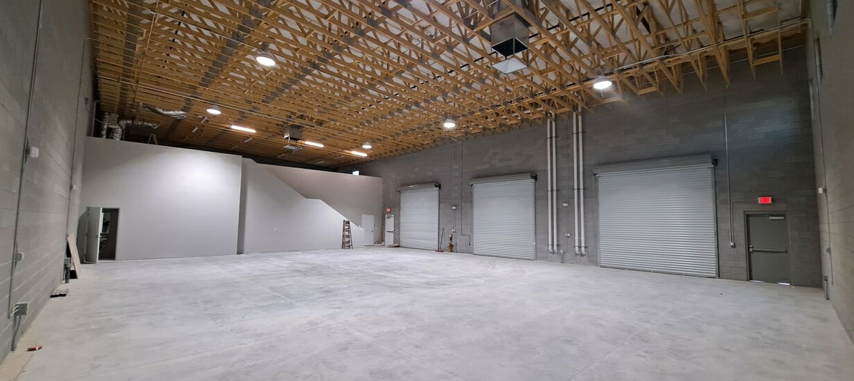
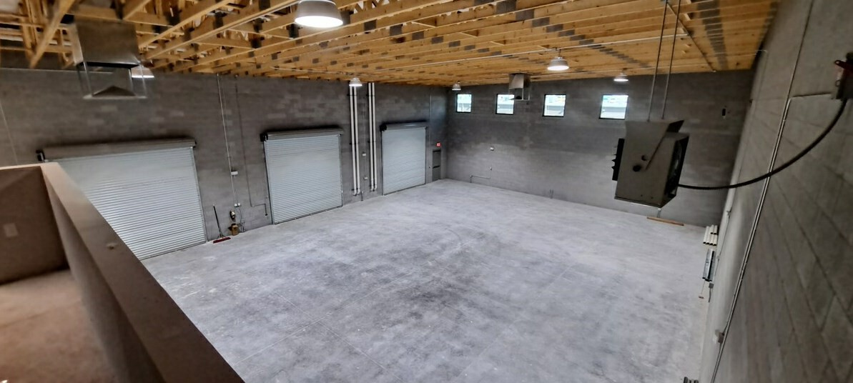
A20230809_093255
A20230809_093348
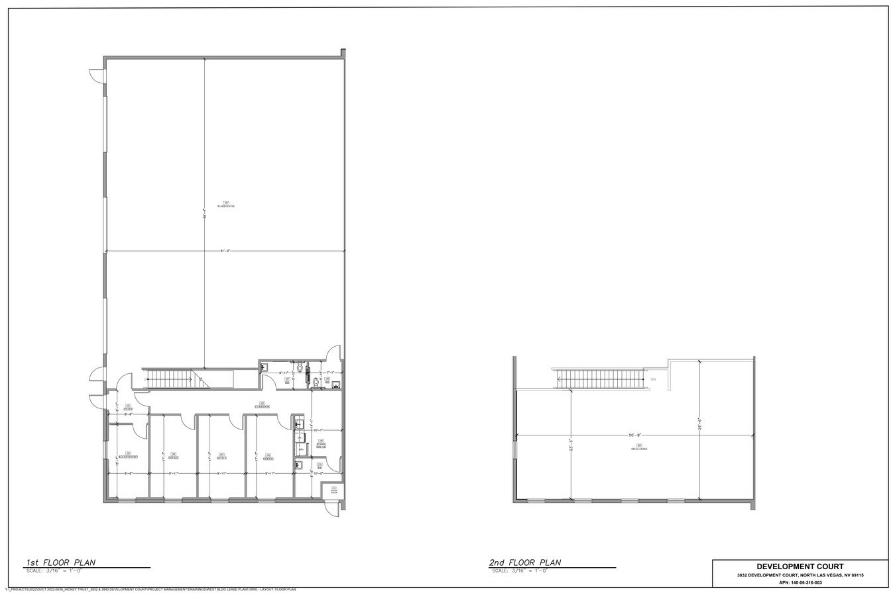
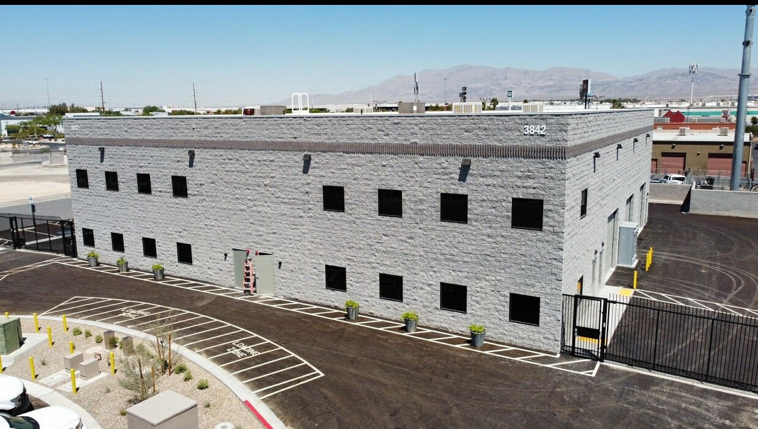
3832 Development Court Floor Plan
A1
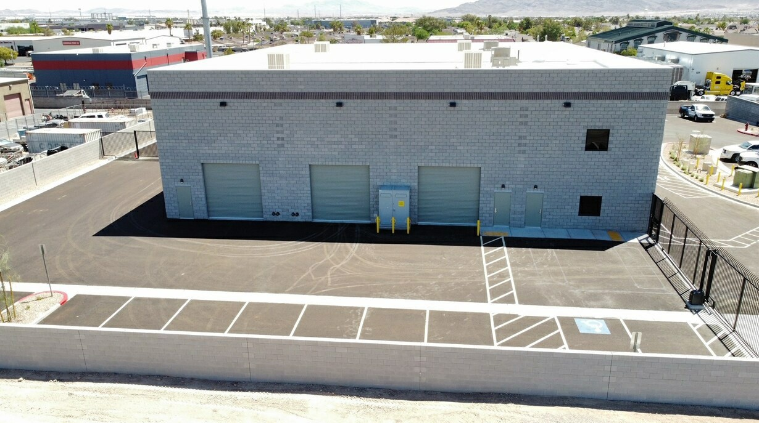
A2

